MINI PROJECT

CASE STUDY:

Find and Work with different types of Alerts.

BASE URL:

[**http://cookbook.seleniumacademy.com/Alerts.html**](http://cookbook.seleniumacademy.com/Alerts.html)

STEPS TO EXECUTE:

1. Open the base URL,the following page will be opened.

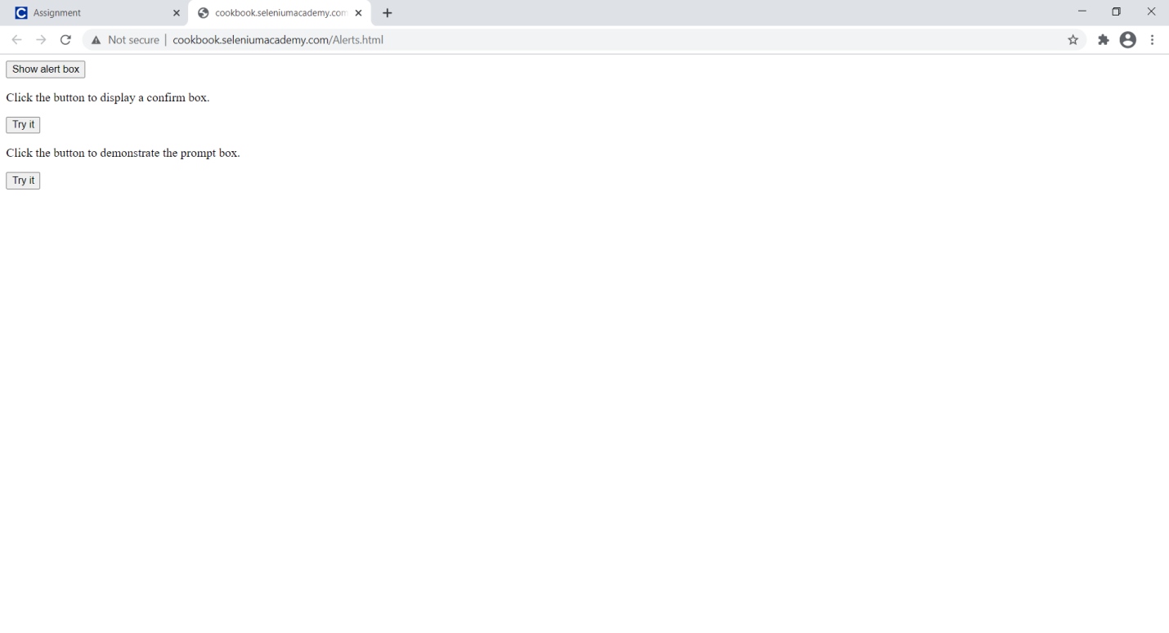

2.click on Show alert box.It will display a pop message with “Hello! I’m alert box”.click on OK button.

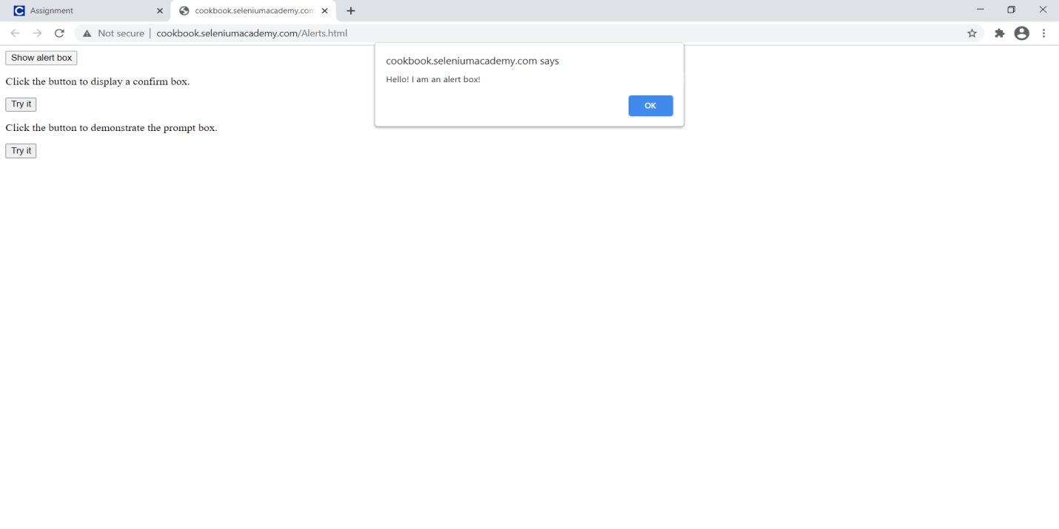

3.click on Try it button in Confirm Alert to display a confirm message.It will display a pop message with “Press a Button!”having OK button and Cancel button.

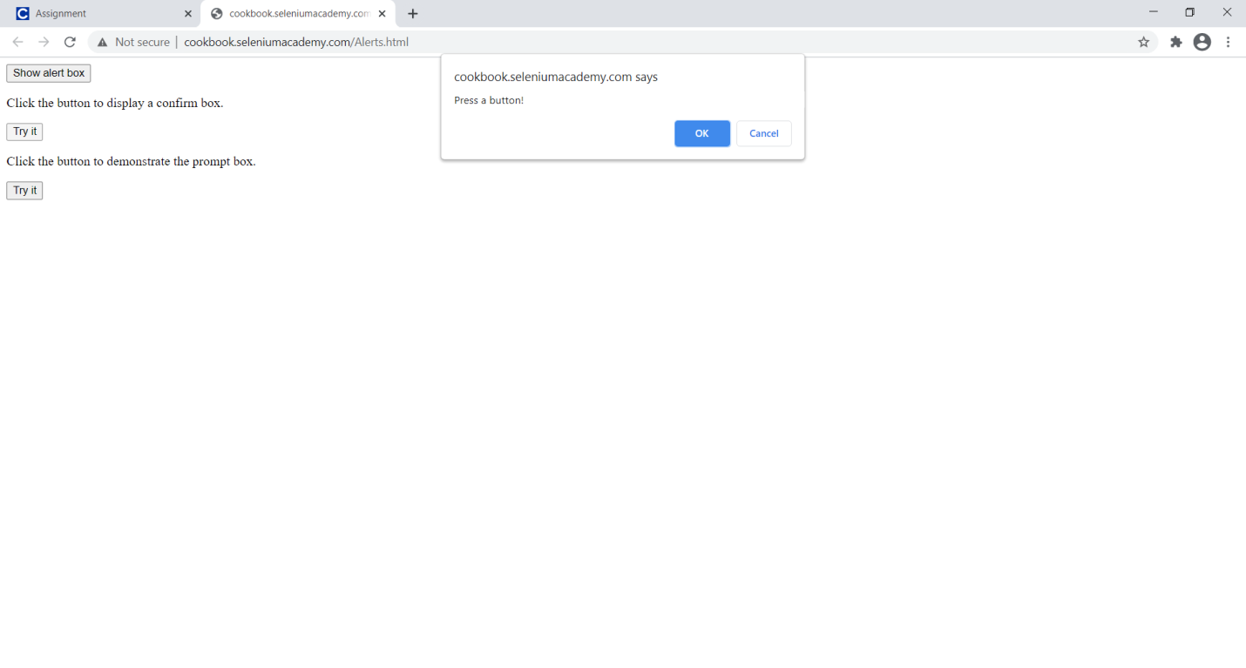

4. Click on Ok Button.Then you will display a message like “You Accepted Alert.”

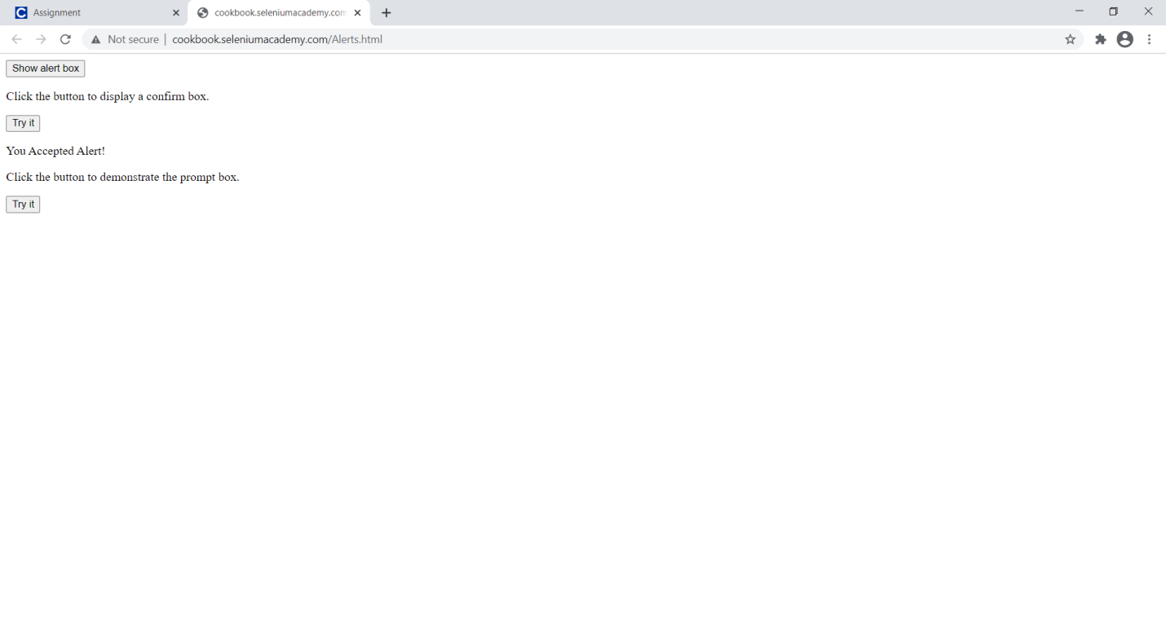

5.Click on Cancel Button.Then you will display a message like “You Dismissed Alert.”

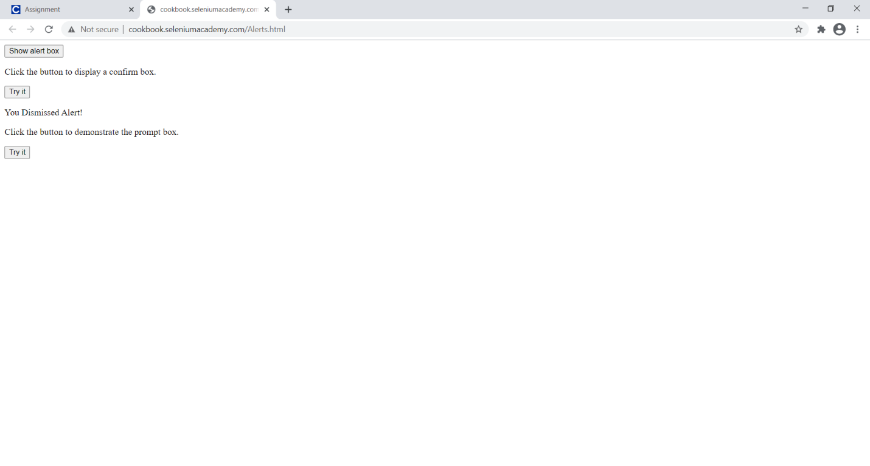

6. Click on Try it button in the Prompt Alert. You will display a message like “Please Enter your Name”,having OK button and cancel button.

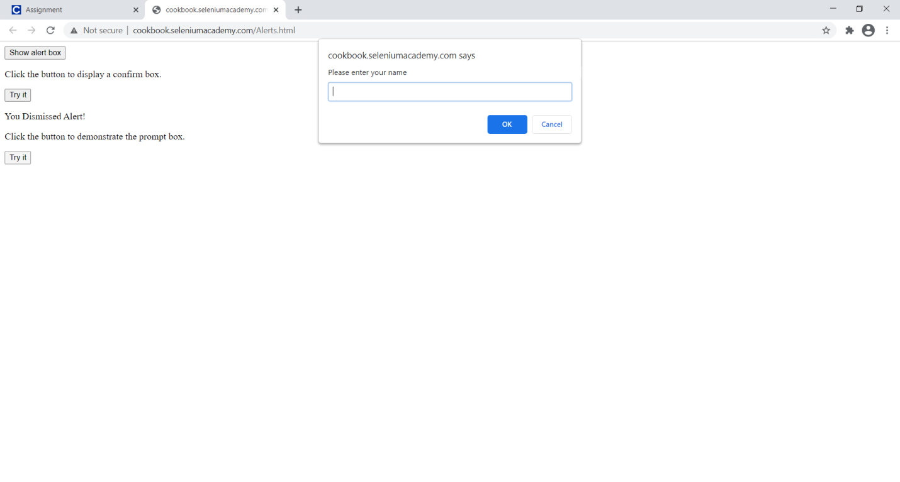7.Enter the name as “Sreehari” in the field and click on OK button. 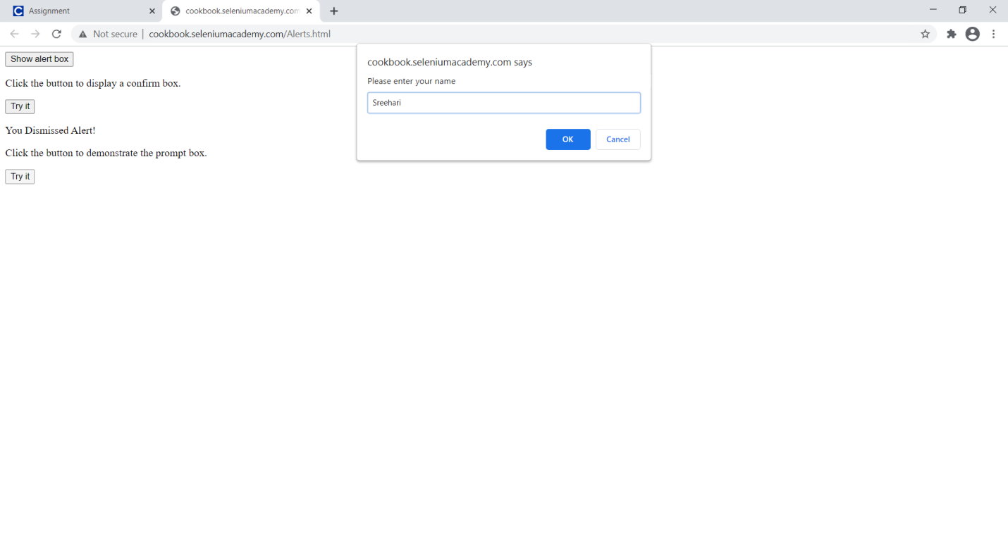

8. Clicking on OK button you will display a message like” Hello Sreehari! How are you today? “

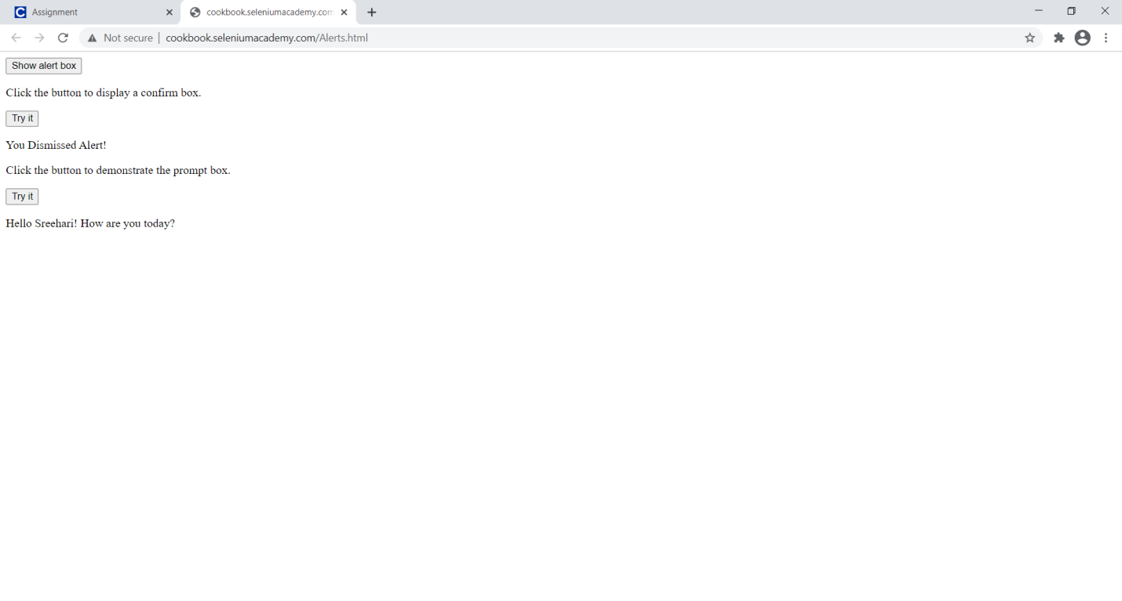

Source code for Referrence:

DriverSetup.Java

**import** java.util.Scanner;

**import** java.util.concurrent.TimeUnit;

**import** java.io.IOException;

**import** org.openqa.selenium.WebDriver;

**import** org.openqa.selenium.chrome.ChromeDriver;

**import** org.openqa.selenium.chrome.ChromeOptions;

**import** org.openqa.selenium.firefox.FirefoxDriver;

**import** org.openqa.selenium.firefox.FirefoxOptions;

**public** **class** DriverSetup

{

**public** **static** WebDriver *driver*;

**public** **static** Scanner *n*;

**public** **static** WebDriver invokeChrome() **throws** InterruptedException, IOException

{

System.*setProperty*("webdriver.chrome.driver","C:\\Users\\mypc\\Downloads\\softwares\\chromedriver_win32\\chromedriver.exe");

ChromeOptions options = **new** ChromeOptions();

options.addArguments("--disable-notifications");//disable the notifications

*driver*=**new** ChromeDriver(options);

//opening the website in particular browser

*driver*.manage().timeouts().implicitlyWait(30, TimeUnit.***SECONDS***);

//this is a wait function which gives enough time to load all pages

*driver*.manage().window().maximize();// Maximize the window

System.***out***.println("--Invoking in Chrome --");

**return** *driver*;

}

**public** **static** WebDriver invokeFirefox() **throws** InterruptedException, IOException

{

System.*setProperty*("webdriver.gecko.driver","C:\\Users\\mypc\\Downloads\\softwares\\geckodriver-v0.29.0-win64\\geckodriver.exe");

FirefoxOptions options = **new** FirefoxOptions();

options.addArguments("--disable-notifications");

*driver*=**new** FirefoxDriver(options);

*driver*.manage().window().maximize();

*driver*.manage().timeouts().implicitlyWait(30, TimeUnit.***SECONDS***);

System.***out***.println("--Invoking in FireFox --");

**return** *driver*;

}

}

Readfile.Java

**import** java.io.FileInputStream;

**import** java.io.IOException;

**import** java.util.Iterator;

**import** org.apache.poi.ss.usermodel.Cell;

**import** org.apache.poi.ss.usermodel.DataFormatter;

**import** org.apache.poi.ss.usermodel.Row;

**import** org.apache.poi.xssf.usermodel.XSSFSheet;

**import** org.apache.poi.xssf.usermodel.XSSFWorkbook;

**public** **class** Readfile

{

**public** **static** String *text*;

**private** **static** XSSFWorkbook *wb*;

**public** **static** String input() **throws** IOException

{

FileInputStream read = **new** FileInputStream("practice.xlsx");

*wb* = **new** XSSFWorkbook(read);

XSSFSheet sheet = *wb*.getSheet("practice");

Row row;

Cell cell;

Iterator<Row> rowiterator = sheet.rowIterator();

**while**(rowiterator.hasNext())

{

row = rowiterator.next();

Iterator<Cell> celliterator = row.cellIterator();

**while**(celliterator.hasNext())

{

cell = celliterator.next();

DataFormatter data = **new** DataFormatter();

*text* = (String) data.formatCellValue(cell);

}

}

**return** *text*;

}

Test.Java:

**import** java.io.IOException;

**import** org.openqa.selenium.Alert;

**import** org.openqa.selenium.By;

**import** org.openqa.selenium.WebDriver;

**import** org.openqa.selenium.WebElement;

**public** **class** Test

{

**public** **static** WebDriver *driver*;

**public** **static** **void** test() **throws** IOException,InterruptedException

{

//Navigating to website

*driver*.navigate().to("http://cookbook.seleniumacademy.com/Alerts.html");

//SIMPLE ALERT

WebElement simple = *driver*.findElement(By.*id*("simple"));

simple.click();

//Alert object is created

Alert alert=*driver*.switchTo().alert();

String message1=alert.getText();

System.***out***.println("Alert box is "+message1);

Thread.*sleep*(2000);

alert.accept();

//CONFIRM ALERT

//ACCEPT

WebElement confirm =*driver*.findElement(By.*id*("confirm"));

confirm.click();

String message2=alert.getText();

System.***out***.println("Alert box is "+message2);

Thread.*sleep*(2000);

alert.accept();

//DISMISS

*driver*.findElement(By.*id*("confirm"));

confirm.click();

Thread.*sleep*(2000);

alert.dismiss();

//PROMPT ALERT

String input = Readfile.*input*();

WebElement prompt= *driver*.findElement(By.*id*("prompt"));

prompt.click();

String message3=alert.getText();

System.***out***.println("Alert box is "+message3);

//Reading input from readfile.java and clicking on ok

alert.sendKeys(input);

Thread.*sleep*(2000);

alert.accept();

//Getting the message associated with each Alert box.

System.***out***.println(input);

Thread.*sleep*(2000);

System.***out***.println(" ");

//Closing the Browser

*driver*.close();

}

//Invoke a Chrome browser

**public** WebDriver createChromeDriver() **throws** InterruptedException, IOException

{

*driver*=DriverSetup.*invokeChrome*();

**return** *driver*;

}

//Invoke a Firefox browser

**public** WebDriver createFireDriver() **throws** InterruptedException, IOException

{

*driver*=DriverSetup.*invokeFirefox*();

**return** *driver*;

}

}

Main.Java

**import** java.io.IOException;

**public** **class** Main

{

**public** **static** **void** main(String args[]) **throws** IOException, InterruptedException

{

Test test=**new** Test();

Test test1=**new** Test();

test.createChromeDriver();

Test.*test*();

test1.createFireDriver();

Test.*test*();

}

}

Additional Information:

1. Chrome and Firefox drivers are used as a browsers to run this project and these are stored in Drivers folder.
2. Input data is given from Readfile.java using ApachePOI.
3. Data is imported from the Practice.xlsx file.

Steps to run Project on Eclipse:

1. Launch Eclipse
2. Click on -> File from menu bar -> Open Project from directory
3. Run -> Main.java from src folder.